**Assignment 1**



**Spring 2023**

**Submitted by: Maaz Habib**

**Registration No.: 20PWCSE1952**

**Class Section:** **C**

“On my honor, as student of University of Engineering and Technology, I have neither given nor received unauthorized assistance on this academic work.”

**Submitted to:**

DR Bilal Habib

**Department of Computer Systems Engineering**

**University of Engineering and Technology, Peshawar**

**Code:**

**#include <reg51.h>**

**#include <stdio.h>**

**void delay(int d){**

**int i,j;**

**for(i=0; i<d; i++){**

**for(j=0; j<250;j++){**

**}**

**}**

**}**

**sbit input = P1^5;**

**sbit led = P1^2;**

**void main()**

**{**

**input =1;**

**// Write your code here**

**while (1)**

**if(input ==0){**

**led = 1;**

**delay(7);**

**led = 0;**

**delay(3);**

**} else{**

**led = 0;**

**delay(7);**

**led = 1;**

**delay(3);**

**}**

**}**

**Circuit diagram:**

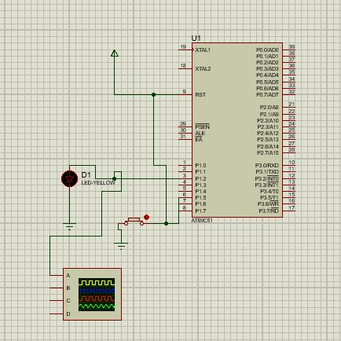

**Output:**

